Detection & Classification of Diabetic Retinopathy using Inception V3 and Xception Architectures

**Ms. V. Sathiya(AssociateProfessor), Bharghavi.J, Deepthi.H, Mathumita.B**

Department of Computer Science & Engineering, Panimalar Engineering College, Chennai-600123,India

# ABSTRACT:

Patients with diabetes usually develop a condition called Diabetic Retinopathy (DR), resulting from the retinal damage. This impairment usually happens when the glucose levels in the blood are elevated, finally causing a blockage in the blood vessels that feed a part of the eye called the retina and finally severing it from the blood supply. Therefore, the eye attempts to produce fresh blood cells. But these cells are either poorly developed or weak. So, it can be leaked out easily. Hence, to lessen the severe effects of this disease, these patients must be diagnosed as soon as possible. Earlier, a number of approaches were put forth to recognise this illness using machine learning algorithms, image processing, and other techniques. The diagnosis process of this disease involves pre-processing of coloured images of the fundus, extraction of clinical features, and classification of retinopathy. In this research, fundus photography of the retina is utilised to accelerate the detection of various kinds of retinopathy caused by diabetes based on Convolutional Neural Network (CNN) pre-trained transfer learning algorithm. Inception V3 and Xception are used in this model to determine and categorise diabetic retinopathy, respectively. As a result, people with this disease can lower their risk of exposure to permanent blindness.

**INDEX TERMS:** Fundus image, retina, image enhancement, diabetic retinopathy, deep learning, microaneurysm, exudates, haemorrhage.

# normalvsdr.jpgINTRODUCTION:

The main reason for vision loss in the world is due to the development of diabetic retinopathy in individuals. The likelihood of evolving retinopathy increases with the duration of diabetes. Diabetic retinopathy happens when the retinal blood vessels are obstructed by the glucose. These ruptured vessels in

the clear-vision region of the retina result in vision loss. The macula, a particular region in the retina where we perceive colour and fine detail, is susceptible to fluid leakage. This fluid makes the macula to swell, causing blurred vision. On the retina's surface, new blood cells might develop in an effort to enhance blood flow there. These delicate, abnormal blood cells can leak and eventually obstruct vision. The Retinopathy disease has no symptoms in its initial stages. Gradually, a few people recognise variations in their vision in the later phases, such as difficulty reading or being unable to see faraway objects. These adjustments could occur and disappear.

***Figure 1*** *Normal Retina & Diabetic Retinopathy*

However, as the disease progressed, a fluid (particularly a gel-like substance) leaks from the vessels of the eye, which eventually develops into gloomy, floating patches or streaks. Sometimes these patches vanish on their own. Therefore, it's imperative to get help right away. Without medical attention, wounds start to bleed, and the haemorrhage might get worse. Beyond a certain point, the person runs the risk of losing vision permanently. Early detection is essential, especially when it comes to delicate organs like the eyes. When individuals with diabetic

retinopathy fail to take the necessary steps to regulate

their glucose levels, a fluid called macular edema may gather in their lenses. This alters the curvature of the lens and affects how the world is perceived. Once the levels of glucose fall, the retinal lens usually returns to its primary shape, and the vision gets better. Improved blood sugar control techniques among diabetic individuals will halt the progression of diabetic retinopathy. A healthy lifestyle includes a proper diet, frequent exercise, managing blood pressure, and abstaining from alcohol and cigarettes.



*Normal vision Diabetic retinopathy*

***Figure 2*** *Vision with diabetic retinopathy*

The adoption of efficient image processing technologies enhanced the effectiveness of the treatment provided to patients. There are many relevant uses for these image processing methods. Since there is a broad spectrum of diseases, many of these uses are in medicines.

Diabetes affects approximately 415 million individuals worldwide, and by 2040, the prevalence is bound to increase to almost 642 million. The predominance of Diabetic Retinopathy in individuals with diabetes extends from 35% to 49%. This issue can be fixed with proper treatment that offers a quick and accurate diagnosis, but it is also essential to recognise the different severity levels of this disease.

The various levels of Diabetic Retinopathy intensity that may affect a person with diabetes include mild DR, moderate DR, and severe DR. In this particular instance of a mild condition, a small fraction of the vessels inside the region of the retina expand like a balloon, called a microaneurysm. It might consequently release fluid into the retina, which could lead to retinal damage. In the circumstances of a moderate condition, as it worsens, the vessels may grow in size even further and lose their ability to carry

blood. In the severe condition, the blood flow is disrupted and the vessels are harmed.

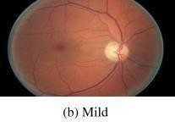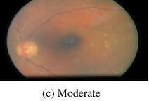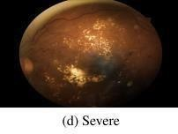

***Figure 3*** *Stages of diabetic retinopathy*

Non-proliferative diabetic retinopathy and proliferative diabetic retinopathy are the two types of diabetic retinopathy. The non-proliferative type is characterised by mild or non-existent symptoms. The retinal blood vessels are weaker, particularly in this type. The non-proliferative type shows different retinopathic symptoms, including haemorrhages (H), cotton wool spots (CWS), hard exudates (HE), microaneurysms (MA), or even soft exudates (SE).The more severe type is proliferative diabetic retinopathy. In the current stage, inadequate flow inside the retina can result in the formation of new, fragile blood vessels and the emergence of vitreous in the eye region. This may cause vision to become blurry since there is fluid leakage from the vessels into the vitreous. Additionally, proliferative diabetic retinopathy ends up causing glaucoma, progressive deterioration of the optic nerve, and the dissociation of the retina due to the formation of scar tissue. The emergence of new cells in the eye's fluid-draining region is a hallmark of proliferative diabetic retinopathy, which significantly raises eye pressure and harms the optic nerve. Without treatment, proliferative diabetic retinopathy results in vision loss or blindness.

# LITERATURE REVIEW:

Throughout the past few decades, numerous image improvement frameworks, notably for Diabetic Retinopathy classification, have been developed to improve computerised disease classifiers. Three distinct CNN sub-models have been created by Harshit Kaushik,Manjit Kaur,Dilbag Singh, Atef Zaguia, Hammam Al-Shazly, and Habib Hamam [1] and are implemented into a unified meta-learner classifier for extracting features. The dataset's visual

variety is increased by using a data augmentation approach. The diagnostic outcome was then given by the metalearner classifier as either healthy (no diabetic retinopathy) or unhealthy (diabetic retinopathy). A different proposed study created a brand-new, precise, and effective algorithm based on the multi- fractal analysis framework to categorise and characterise any complicated forms and branching patterns seen in biology and physics. Using multi- fractal analysis as a screening method for the early diagnosis of retinal disorders is supported by this study's substantial body of research. The Support Vector Machine (SVM) technique was utilised throughout the studies to automate the diagnostic procedure and increase the resulting accuracy. A CNN model of DenseNet169 architecture coupled with CBAM for augmentation of power was presented by Mariam Foud, Amr T. Abdul-Hamid, and Mohammed M. Farag [2].The suggested approach reduced the burdenof space and time complexity while demonstrating solid performance and meeting equivalent quality criteria. The quality of the fundus pictures was further improved with a 2-D Gaussian filter. The weighted loss function was then created using INS to address the imbalance of the class and enhance the prediction of the model for the entire class. In their study [3] on the automatic grading of retinopathy diabetes employing deep networks, Zhentao Gao, Jixiang Guo, Jie Li, Zhang Yi,Yuanyuan Chen, Jie Zhong, and Zhang Yi introduced a unique set of data that is modest in proportions and is compiled with a new labelling scheme. It is also suggested to use a pre- processing pipeline to convert photos of the fundus into the standardised form. The trained models may be seen and analysed to get insights into how they identify patients based on the fundus pictures and to support their diagnostic efficacy from various angles. The learned models are deployed for clinical applications on the cloud platform and offer trial clinical services to multiple hospitals online. To improve the effectiveness and precision of the classification of the retinopathy phases in coloured fundus photos, Ahmad Khan, Fiaz Gul Khan, Zia Ur Rehman, Zubair Khan, Sehrish Qummar, Farman Ali, Sajid Shah, and Sangheon Pack [4] made architectural improvements to the pre-existing CNN and cut back on the learnable characteristics. The performance

metrics of the suggested model are validated using unbalanced versions of the Kaggle dataset. An autonomous approach based on deep learning was created by Muhammad Hussain, Fahman Saeed, and Hatim A. Aboalsamh [5] for rating retinal fundus images and sending Diabetic Retinopathy patients to an ophthalmologist at an early stage. Using a two- stage transfer learning technique, the system was constructed from the model that is pre-trained. Initially, the ImageNet technique was used to pretrain the CNN models. Second, the FC layers had a huge number of learnable parameters and encoded the high- level information pertinent to the natural images.

# DETECTION AND CLASSIFICATION OF DIABETICRETINOPATHY:

From the literature, it is inferred that no previous paper has employed hybrid models for diabetic retinopathy identification and categorization, and the accuracy of the prototype is lower than the prototype implemented here. The model presented in the base paper is used to identify whether a person has been affected by diabetic retinopathy. During pre- processing, one model and two different image enhancement strategies were employed. The fundus images' quality has been improved using an enhancement strategy. The model is mainly concentrated on upgrading the efficiency of the retinal images and increasing accuracy through circle cropping. Here, retinopathy detection is carried out following the image processing stage to enhance the highlights that were retrieved from the image. The feature extraction of the ResNet50 offers rich features in order to assist the categorization stage. The quality and contrast of the image were enhanced using the Gaussian blur algorithm and a circle crop. The outcome of the proceeding is the processed image. However, the existing system cannot be used to recognise the nature of Diabetic Retinopathy. The ResNet50 model has been used for extracting features, which increased time consumption and reduced the ability of the prediction (92% compared to the proposed model). The literature also indicates the need for further research into the most recent enhancement methods for issues with sharpness features, contrast, and denoising since they are closely

related to the outcomes of disease diagnostics. Therefore, the current paper illustrates a highlighting approach for the images in the fundus region to boost the quality by using two techniques: a median filter for denoising an adaptive histogram equalization to strengthen the contrast. The objective of this research is to create an internet application that recognises whether an individual has diabetic retinopathy. If an individual has been affected by this disease, this model will determine the severity and category of the retinopathy. Attributed to the reason that this app is online, anybody with internet service can easily use it to check if they have Diabetic Retinopathy by uploading retinal images as an input to the system. Two different deep learning techniques were used in this case to boost accuracy by 98%. Inception V3 is employed for detection, and Xception is applied for classification. For detection, initially we classified the fundus images into two different classes, where each class has a label named "diabetic retinopathy and non- diabetic retinopathy". We trained the Inception V3 model to detect whether a person has Diabetic Retinopathy according to the input image (fundus image) given by the patient. For classification, this model classifies the images that have retinopathy into three more classes, and each of these classes has a label named "microaneurysm," "exudate, or "haemorrhage". We trained the Xception model to determine the type of diabetic retinopathy.

# BLOCK DIAGRAM:

The systems that were developed recently were not able to detect most tiny vessels and lesions simultaneously. Since the accuracy is lower due to the image quality issue, it cannot be used to categorise the type and intensity of the disease. In an order to provide the early clinical recognition of the disease along with its types, this paper represents a model for strengthening the colour of the fundus images using a noise removal technique called a median filter and an image enhancement technique called adaptive histogram equalisation. Figure 4 illustrates the architecture of the system. To do so, processing for that enhancement was done first, followed by the diagnosis of diabetic retinopathy and then categorization.

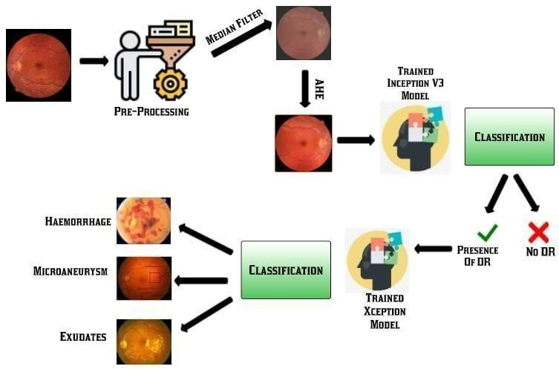

***Figure 4*** *System architecture*

# METHODOLOGY:

The images of the fundus, both with and without disease, will be collected and saved in different folders. The images will first go through preprocessing after being acquired before being used to train the Inception V3 model. The following phase involves creating three folders and placing the fundus images with haemorrhages, microaneurysms, and exudates inside each separate folder. Xception will be trained using these images, and its performance will be measured based on its accuracy.

1. **IMAGE AQUISITION:** In image processing and image acquisition contexts, this is a method of extracting an image from a certain source, generally a hardware-based source. The IDRiD database is used to gather retinal images.
2. **PRE-PROCESSING:** The second stage is preprocessing, which includes image resizing and noise removal. The noise in the retinal image is eliminated using a median filter.
3. **DIABETIC RETINOPATHY DETECTION**: After preprocessing, features from retinal images are extracted and classified using the V3 prototype of Inception. The input size for Inception V3 is 299 by 299 pixels with 42 layers. The proposed model was trained to create a classification prediction that divides the retinal image into normal and abnormal categories based on hyper-parameters like epochs, learning rate, dropout, and optimizer (ADAM) (diabetic retinopathy).
4. **DR CLASSIFICATION:** Using the Xception deep learning model, this module classified the images of diabetic retinopathy into three types using abnormal retinal images (DR). The proposed model was trained to build a classification prediction that categorizes the Diabetic Retinopathy retinal image into three types, such as microaneurysms, hemorrhages, and exudates, based on hyper parameters like epochs, learning rate, dropout, and optimizer (ADAM).
5. **PERFORMANCE MEASURE:** Finally, the effectiveness of this prototype was measured in terms of precision, recall, F1 score performance metrics, and accuracy.
6. **DATASET:** The IDRiD database is used to get the dataset. Each subject's two eyes are represented by images in this dataset. As was already mentioned, ophthalmologists classify all photographs using the standard severity scale. For training and validation, the dataset is split into two sets, each of which contains images ofthe eyes taken from a different patient. By altering the copies of the existing dataset, the dataset will first be augmented to increase the training dataset. Making small adjustments to the current dataset or creating new data using deep learning are both included. The dataset will be loaded and preprocessed after the data augmentation has been completed. The information is then divided into five categories, as shown in Table 1.

|  |  |  |  |
| --- | --- | --- | --- |
| Classname | Train | Validate | Total |
| Normal | 34 | 16 | 50 |
| Abnormal | 34 | 16 | 50 |
| Microaneurysm | 28 | 8 | 36 |
| Exudates | 27 | 6 | 33 |
| Haemorrhage | 27 | 13 | 40 |

***Table 1*** *Distribution of classes*

1. **IMAGE PRE-PROCESSING:** One intuitive method for boosting the effectiveness of this prototype is to improve the generated image quality. This model uses two techniques for improving the quality of the image without any loss of data:

removing image noise using a median filter (MF) and increasing image contrast by using adaptive histogram equalization (AHE).

**MEDIAN FILTER:** This is a filtering technique used during preprocessing for denoising of images. The filter is extremely important in image processing because it is well known for preserving edges since it removes noise. The current system makes use of gaussian blur. The images may occasionally lose important details as a result. Therefore, accuracy is increased by using the median filter.

# ADAPTIVE HISTOGRAM EQUALISATION:

Once the noise has been removed from the image, this technique enhances the image contrast. The image's luminance values are redistributed using histograms that are computed, each of which corresponds to a different region in the image.

1. **TRAINING PROCESS FOR INCEPTION V3& XCEPTION MODELS:** Once the images are preprocessed, the normal and abnormal retinopathic images are used to train the Inception V3 model for the detection of diabetic retinopathy. Similarly, fundus images that have microaneurysms, exudates, and haemorrhage are used to train the Xception model for severity classification.

# ALGORITHM DESCRIPTION

1. **INCEPTION V3 (DETECTION)**

The V3 model of Inception is an image classification model that includes deep learning constructed using CNN. The model employs a number of network optimization techniques for better alternative adaptation. Especially in contrast to the V1 Inception model and the V2 Inception model, the V3 model is more efficient and features a deeper network, but its speed is unaffected. Inception V3 uses auxiliary classifiers to regularize and is computationally less expensive. The 42-layer Inception V3 model of Inception, has a fairly low failure rate compared to its predecessors. The main enhancements to the Inception V3 model are spatial factorization into asymmetric convolutions, factorization into smaller convolutions and efficient grid size reduction.

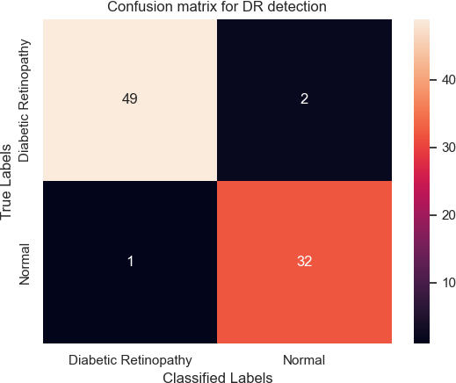

***Figure 5*** *Confusion matrix for DR detection*

To determine if a person has diabetic retinopathy, the model uses Inception V3. The Inception V3 model is the advanced version of the Inception V1 and V2 models. Since the V3 model possesses a deeper network, this increases the efficiency of the model while maintaining speed, one of its main benefits. It is more affordable computationally. To regularize, it makes use of auxiliary classifiers.

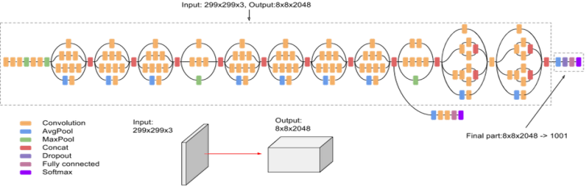

***Figure 6*** *InceptionV3 architecture*

# XCEPTION (CLASSIFICATION)

The "Extreme Version of Inception" is what Google refers to as Xception. It is made up of a deep convolutional neural network that is 71 layers deep. On the dataset of the ImageNet , Inception V3 is only marginally outperformed by Xception, which performs vastly better on a huge sample of 17,000 classes for image classification.

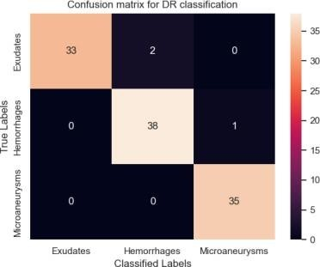

***Figure 7*** *Confusion matrix for DR classification*

The fact that it has parameters similar to those of Inception means that the entry flow is the first step in this process, followed by the middle flow, which is performed eight times, and finally the exit flow, which is applied to the data.

# Original Depth-wise Separable Convolution in Xception

The original depth-wise separable convolution is the depth-wise convolution that comes after the point- wise convolution.

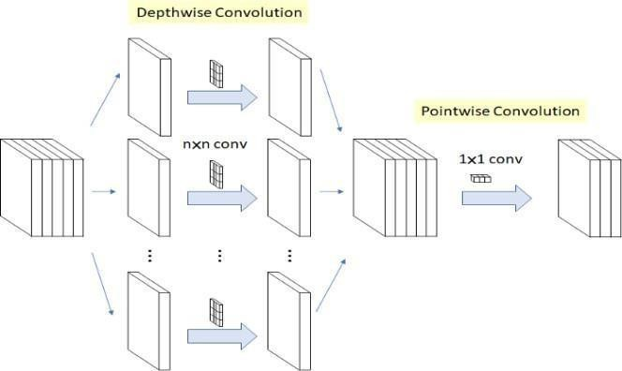

***Figure 8*** *Original depth-wise separable convolution in Xception*

1. The channel-wise nxn spatial type of convolution is the depth-wise convolution. Given the five channels in the figure above, then there would be five times as many spatial convolutions.
2. In order to change the dimensions, the pointwise convolution is a 1x1convolution. Convolution between all of the channels is not required, as it would be with conventional. The model is lighter and has fewer connections as a result.

# Modified Depthwise Separable Convolution in Xception

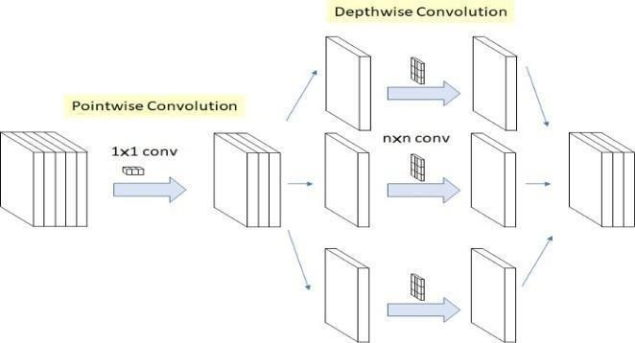

***Figure 9*** *Modified depth-wise separable convolution in Xception*

The depthwise convolution is preceded by the pointwise convolution. The Inception V3 module's requirement that 1x1 convolutions be performed before any nxn spatial convolutions served as the impetus for this modification. As a result, it differs slightly from the original.

# TWO MINOR DIFFERENCES:

1. **The sequence of operations:** When compared to the original depth-wise separable convolutions, the 1x1 convolution is performed first by the modified depth-wise separable convolution, pursued by the channel-wise spatial convolution (for example, in Tensor Flow).This is said to be insignificant because, when used in stacked settings, all of the chained inception modules only exhibit slight variations at their beginning and conclusion.
2. **The Existence or Lack of Non-Linearity:** The Inception architecture displays non-linearity once the initial action is done. Since it doesn't possess intermediary ReLU nonlinearity in the architecture of Xception, the revised depth-wise separable convolution with various activation units is put to the test. The Xception without an intermediating stimulation has the best accuracy when contrasted with the ones employing either ReLU or ELU.

# PERFORMANCE ANALYSIS:

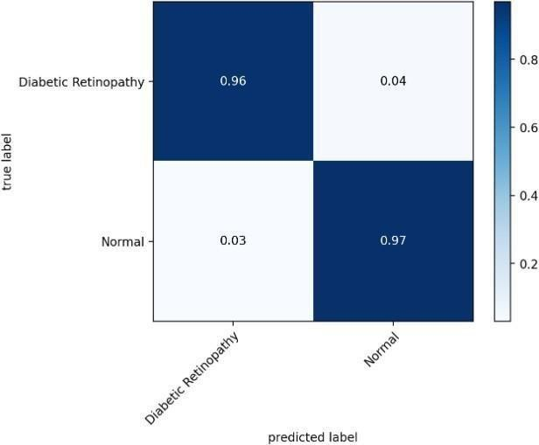

***Figure 10*** *Performance analysis for DR detection*

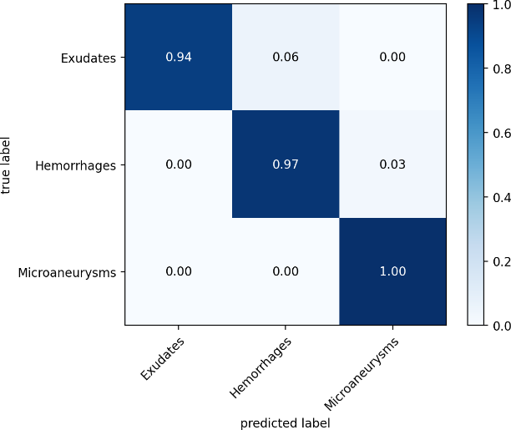

***Figure 11*** *Performance analysis for DR classification*

Using the above-mentioned confusion matrix, the effectiveness of the Inception V3 and Xception models for detection and classification of retinopathy is demonstrated. The Inception V3 model's accuracy is 96%, whereas the Xception model's accuracy is 97%.

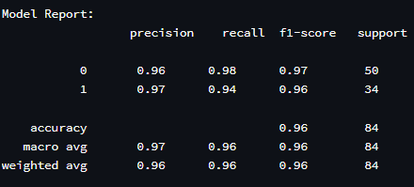

***Figure 12*** *Detection report*

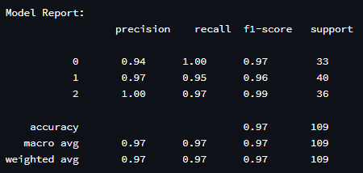

***Figure 13*** *Classification report*

As a result, these models' overall accuracy is 97%. The model employed 84 photos for the performance study of the Inception V3 and 109 fundus photos for the performance monitoring of the Xception model.

# TEST CASES:

***Table 2*** *Test Cases*

|  |  |  |  |  |
| --- | --- | --- | --- | --- |
| **Action** | **Input** | **Expected Output** | **Actual Output** | **Test Result** |
| Launch streamlit application  using“streamlit runapp.py” | http://localhost:8501/ | DR  detection and classification web application | DR  detection and classification web application | Pass |
| Detection of DR | Upload fundus photos withDR | DR | DR | Pass |
| Classification of DR | Upload fundus photos withDR | Exudates | Exudates | Pass |
| Detection of DR | Upload fundus  photos without DR | No DR | No DR | Pass |

# CONCLUSION & FUTURE ENHANCEMENTS:

Diabetic retinopathy is a major issue since it affects so many people nowadays. In many cases, the early recognition of diabetic retinopathy can avert significant retinal damage, and diagnostic research has proven that improving the picture quality of the fundus region is the best way to improve the quality of screening systems. Such enhancements make it easier for patients in both urban and rural locations to receive care by lowering screening programme expenses and saving time. In this research, we suggested a model relying on the Inception V3 and Xception architectures. Depending on hyper

# DISCUSSION AND RESULTS:

Automatic grading of Diabetic Retinopathy has been investigated intensively in recent times by research communities, particularly with advancements in deep learning algorithms. Diabetic retinopathy is indeed a diabetes related complicating factor that induces vision problems. It is prompted by damaging the vessels in the retina that possess thin tissues. In the mild phase or moderate phase, the disease does not exhibit signs. However, at a critical level, it results in lifetime blindness. For detection, this model is trained using the Inception V3 architecture to check whether a person has been affected with retinopathy depending on the input image, i.e., images of the fundus. Automatic grading of Diabetic Retinopathy has been investigated intensively in recent times by research communities, particularly with advancements in algorithms related to deep learning. For classification, the prototype is trained using the Xception architecture to determine the kind of diabetic retinopathy possessed by a patient, derived from the fundus image provided by the patient. The accuracy of the suggested model achieved 97%.

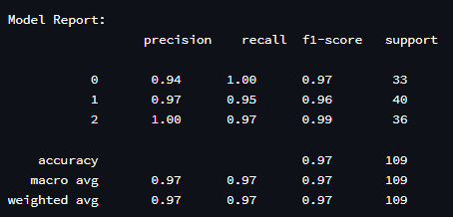

***Figure 14*** *Model report*

parameters, the suggested network models were enhanced for better categorization. The outcome of the results proves that the CNN prototype model we've suggested can correctly categorise Diabetic Retinopathy kinds. Since artificial intelligence technology is advancing, a potential future extension of this work entails the development of a smart phone app that would take eye images taken with the device's camera and process them to determine whether or not Diabetic Retinopathy has been experienced by the user and, if so, classify the types of Diabetic Retinopathy. By implementing this future model, people get to save their time from visiting the ophthalmological hospitals and keep the ophthalmological hospitals alive in remote areas through this application.

# REFERENCES:

* 1. Kaushik, H., Singh, D., Kaur, M., Alshazly, H., Zaguia, A., &Hamam, H. (2021). Diabetic retinopathy diagnosis from fundus images using stacked generalization of deep models. IEEE Access, 9, 108276-108292.
  2. Farag, M. M., Fouad, M., & Abdel-Hamid, A. T. (2022). Automatic severity classification of diabetic retinopathy based on denseNet and convolutional block attention module. IEEE Access, 10, 38299- 38308.
  3. Gao, Z., Li, J., Guo, J., Chen, Y., Yi, Z., &Zhong, J. (2018). Diagnosis of diabetic retinopathy using deep neural networks. IEEE Access, 7, 3360- 3370.
  4. Mustafa, H., Ali, S. F., Bilal, M., &Hanif, M. S. (2022). Multi-stream deep neural network for diabetic retinopathy severity classification under a boosting framework. IEEE Access, 10, 113172- 113183.
  5. Khan, Z., Khan, F. G., Khan, A., Rehman, Z. U., Shah, S., Qummar, S., & Pack, S. (2021). Diabetic retinopathy detection using VGG-NIN a deep learning architecture. IEEE Access, 9, 61408-61416.
  6. Saeed, F., Hussain, M., &Aboalsamh, H. A. (2021). Automatic diabetic retinopathy diagnosis using adaptive finetuned convolutional neural network. IEEE Access, 9, 41344-41359.

[7] Zeng, X., Chen, H., Luo, Y., & Ye, W. (2019). Automated diabetic retinopathy detection based on binocular siamese-like convolutional neural network. IEEE access, 7, 30744-30753.

1. Liu, T., Chen, Y., Shen, H., Zhou, R., Zhang, M., Liu, T., & Liu, J. (2021). A novel diabetic retinopathy detection approach based on deep symmetric convolutional neural network. IEEE Access, 9, 160552-160558.
2. Atlas, D. (2015). International diabetes federation.IDF diabetes atlas. Brussels: international diabetes federation.
3. Das, A. (2016). Diabetic retinopathy: battling the global epidemic. Investigative ophthalmology & visual science, 57(15), 6669-6682.
4. Rahim, S. S., Palade, V., Jayne, C., Holzinger, A., &Shuttleworth, J. (2015). Detection of diabetic retinopathy and maculopathy in eye fundus images using fuzzy image processing. In Brain Informatics and Health: 8th International Conference, BIH 2015, London, UK, August 30-September 2, 2015. Proceedings 8 (pp. 379-388). Springer International Publishing.
5. Walter, T., Klein, J. C., Massin, P., &Erginay,

A. (2002). A contribution of image processing to the diagnosis of diabetic retinopathy-detection of exudates in color fundus images of the human retina. IEEE transactions on medical imaging, 21(10), 1236- 1243.

1. Subhashini, R., Nithin, T. N. R., &Koushik, U.

M. S. (2019). Diabetic retinopathy detection using image processing (gui). International Journal of Recent Technology and Engineering, 8(2).

1. Yun, W. L., Acharya, U. R., Venkatesh, Y. V., Chee, C., Min, L. C., & Ng, E. Y. K. (2008). Identification of different stages of diabetic retinopathy using retinal optical images.Information sciences, 178(1), 106-121.
2. Li, X., Pang, T., Xiong, B., Liu, W., Liang, P., & Wang, T. (2017, October). Convolutional neural networks based transfer learning for diabetic retinopathy fundus image classification. In 2017 10th international congress on image and signal processing, biomedical engineering and informatics (CISP-BMEI) (pp. 1-11).IEEE.
3. Kwasigroch, A., Jarzembinski, B., &Grochowski, M. (2018, May). Deep CNN based decision support system for detection and assessing the stage of diabetic retinopathy. In 2018 International Interdisciplinary PhD Workshop (IIPhDW) (pp. 111-116).IEEE.
4. Masood, S., Luthra, T., Sundriyal, H., & Ahmed, M. (2017, May). Identification of diabetic retinopathy in eye images using transfer learning. In 2017 international conference on computing, communication and automation (ICCCA) (pp. 1183- 1187).IEEE. [17] Xu, K., Feng, D., &Mi, H. (2017). Deep convolutional neural network-based early automated detection of diabetic retinopathy using fundus image.Molecules, 22(12), 2054.
5. Rahim, S. S., Palade, V., Almakky, I., &Holzinger, A. (2019). Detection of diabetic retinopathy and maculopathy in eye fundus images using deep learning and image augmentation. In Machine Learning and Knowledge Extraction: Third IFIP TC 5, TC 12, WG 8.4, WG 8.9, WG 12.9 International Cross-Domain Conference, CD-MAKE 2019, Canterbury, UK, August 26–29, 2019, Proceedings 3 (pp. 114-127). Springer International Publishing.
6. Doshi, D., Shenoy, A., Sidhpura, D., &Gharpure, P. (2016, December). Diabetic retinopathy detection using deep convolutional neural networks. In 2016 international conference on computing, analytics and security trends (CAST) (pp. 261-266). IEEE.
7. Pratt, H., Coenen, F., Broadbent, D. M., Harding, S. P., &Zheng, Y. (2016). Convolutional neural networks for diabetic retinopathy.Procedia computer science, 90, 200-205.
8. Sinthanayothin, C., Boyce, J. F., Williamson, T. H., Cook, H. L., Mensah, E., Lal, S., & Usher, D. (2002). Automated detection of diabetic retinopathy on digital fundus images.Diabetic medicine, 19(2), 105-112.
9. Pal, R., Poray, J., &Sen, M. (2017, May). Application of machine learning algorithms on diabetic retinopathy.In 2017 2nd IEEE International Conference on Recent Trends in Electronics, Information & Communication Technology (RTEICT) (pp. 2046-2051).IEEE.
10. Arcadu, F., Benmansour, F., Maunz, A., Willis, J., Haskova, Z., &Prunotto, M. (2019). Deep learning algorithm predicts diabetic retinopathy progression in individual patients. Npj Digital Medicine, 2 (1).
11. Xu, L., &Luo, S. (2010). A novel method for blood vessel detection from retinal images.Biomedical engineering online, 9, 1-10.
12. Tymchenko, B., Marchenko, P., &Spodarets, D. (2020). Deep learning approach to diabetic retinopathy detection.arXiv preprint arXiv:2003.02261.
13. “Preprocessing in diabetic retinopathy,” accessed: 2020- 08-25. [Online]. Available: https:/[/www.kaggle.com/ratthachat/aptoseyepreproc](http://www.kaggle.com/ratthachat/aptoseyepreproc) essing-in-diabetic-retinopathy .
14. Tan, M., & Le, Q. (2019, May). Efficientnet: Rethinking model scaling for convolutional neural networks.
15. Stitt, A. W., Curtis, T. M., Chen, M., Medina,

R. J., McKay, G. J., Jenkins, A., ...& Lois, N. (2016). The progress in understanding and treatment of diabetic retinopathy.Progress in retinal and eye research, 51, 156-186.

1. Rakhlin, A. (2017). Diabetic Retinopathy detection through integration of Deep Learning classification framework.BioRxiv, 225508.
2. Lam, C., Yi, D., Guo, M., & Lindsey, T. (2018). Automated detection of diabetic retinopathy using deep learning.AMIA summits on translational science proceedings, 2018, 147.
3. Chetoui, M., &Akhloufi, M. A. (2020). Explainable end-to-end deep learning for diabetic retinopathy detection across multiple datasets.Journal of Medical Imaging, 7(4), 044503- 044503.
4. Kauppi, T., Kalesnykiene, V., Kamarainen, J. K., Lensu, L., Sorri, I., Raninen, A., ...&Pietilä, J. (2007, September). The diaretdb1 diabetic retinopathy database and evaluation protocol.In BMVC (Vol. 1, No. 1, p. 10).
5. Li, T., Gao, Y., Wang, K., Guo, S., Liu, H., & Kang, H. (2019). Diagnostic assessment of deep learning algorithms for diabetic retinopathy screening. Information Sciences, 501, 511-522.
6. Porwal, P., Pachade, S., Kamble, R., Kokare, M., Deshmukh, G., Sahasrabuddhe, V., &Meriaudeau, F. (2018). Indian diabetic retinopathy image dataset (IDRiD): a database for diabetic retinopathy screening research. Data, 3(3), 25.
7. Fong, D. S., Aiello, L., Gardner, T. W., King,

G. L., Blankenship, G., Cavallerano, J. D., ...& American Diabetes Association. (2004). Retinopathy in diabetes.Diabetes care, 27(suppl_1), s84-s87.